(Approx. 640 words)

Co-Author Word 2016 Documents in Real Time
By Nancy DeMarte, 1st Vice President, Sarasota Technology User Group, FL
November 2016 issue, Sarasota Technology Monitor
www.thestug.org
ndemarte (at) verizon.net

Sometimes we need to get another person’s input on a document while we’re composing it. In the past, we had to email versions of documents back and forth, with markups and comments. Office 2013 introduced a system where two users could see the same document on their screens at the same time, and both could make changes, although the changes weren’t visible to the other person until they were saved. Office 2016 has upgraded and simplified this process. Now two or more users can edit the same document at the same time from different locations, and both can see changes being made as they occur. This is called “real time co-authoring.” It isn’t difficult at all. And it works with Word documents, Power Point presentations, and Excel workbooks. I’ll use Word 2016 in Windows 10 to explain the steps:

1. Be sure you have OneDrive active on your computer, which might involve signing in to your Microsoft account. This free cloud location, which is built into recent Office versions, is where you can store documents and access them from anywhere over the Internet.
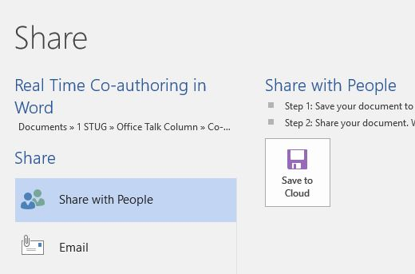
2. Create a folder in OneDrive just for the purpose of co-authoring, and give it a name, like Share or Co-Author. Then save your document to this folder by clicking the File tab – Share – Share with People - Save to Cloud. (Fig. 1) Navigate to your One Drive’s Co-Author folder and click Save.
Figure 1 - Share window in Word 2016


3. Now you are ready to invite a person or team to join you to edit your document. Click the Share icon on the right end of the ribbon. (Fig. 2) In the ‘Invite people’ box, enter one more email addresses or names to access your Contacts list. Leave ‘Can edit’ as the choice and add a short message, if desired.
Figure 2 – Share icon above ribbon

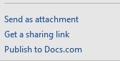
4. Then choose a sharing method from those at the bottom of the Share pane. I prefer to use “Get a Sharing link” (Fig. 3) because my co-author will find his document opening either in his version of Word or in Word Online if he doesn’t have Word 2010 or later on his computer. Word Online offers fewer editing options, but it works well for most editing tasks and can be used even by people who don’t have Word at all.
Figure 3 - Sharing Options list

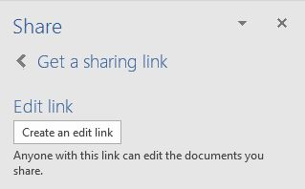
Click “Create an edit link,” (Fig. 4) then highlight the link that appears, and click Copy. Close the Sharing pane, open a new email message, paste the link into it, and send it to your co-author(s). Anyone who gets this link will be able to edit your document.

Figure 4 – Create an edit link dialog box


5. Your editing partner has a choice of whether to let you see his changes as they are being made. To do this, he must click the File tab – Options – General and, in the Real Time Collaboration section, click Always in the drop down menu. This option can be changed at any time. If he has chosen not to let you see changes in real time, you can only see them when he saves the document. During the editing process, colored flags appear in the spot each editor is working. Alerts appear when an editor arrives or leaves. Co-editors can communicate with each other during editing by clicking Comments in the ribbon at the top of the page to chat.
Figure 5 - Share icon showing one co-author

The best way to learn this process is to experiment. Ask a friend to be your test co-author and go through the steps. As usual, practice, if done properly, makes perfect.

